
SHIRE HIGHLANDS EDUCATION DIVISION
2026 MALAWI SCHOOL CERTIFICATE OF EDUCATION MOCK
EXAMINATION
ADDITIONAL MATHEMATICS PAPER II

MARKING KEY

- a. $\frac{2(n\left(n+1\right)}{2}$ +n = 15 1 mk
n² +n + n-15 = 0
n² +2n -15 = 0 1 mk
(n +5) (n-3) =0 1 mk
n =3 or -5 1 mk
n =3 1 mk
b. x +6x + (3)² + y² – 2y + (-1)² = 39 + 9 +1
1 mk
(x +3)² + (y - 1)² = 49 1 mk
(x +3)² + (y - 1)² = 7² 1 mk
Centre (-3, 1) 1 mk
Radius = 7 units 1 mk
- a. Cos$θ= \frac{-2i. 6i+0j.j+4k.3k}{\sqrt{{ 4^{2}+(-2)}^{2}} ×\sqrt{{6^{2}+1^{2}+3}^{2}} }$
2 mk
= $\frac{-12+12}{\sqrt{20} × \sqrt{46}}$ 1 mk
= $\frac{0}{\sqrt{920}}$ 1 mk
$θ=\cos^{-1}\left(0\right)=90°$ 1 mk
b. $\sum_{k=0}^{∞}{\frac{1}{2^{k}}}$
. $\frac{1}{2^{k}}$ 2 mk
. k = 0 1 mk
K = $∞$ 1 mk
- a. U – V = 9i – 2j + 4k
-(3i -6j -3k)
= 6i +4j +7k 1 mk
|U – V|= $\sqrt{{6^{2}+4^{2}+7}^{2}}$
= $\sqrt{36+16+49}$ 1 mk
= $\sqrt{101}$
= 10.05 1 mk
2|u – v| = 2$×10.05$
= 20.10 1 mk
b. Test using partial sum
$$\int{n= \frac{3}{3^{n+1}}}$$
$\int{0= \frac{3}{3^{0+1}}}$ = 1 $\frac{1}{2}$ mk
$\int{1= \frac{3}{3^{2}}}$ +1 = 1.33 1 mk
$\int{2= \frac{3}{3^{3}}}$ +1.33 = 1.44 1 mk
$\int{3= \frac{3}{3^{4}}}$ +1.44 = 1.47 1 mk
$∴ \sum_{n=0}^{∞}{\frac{3}{3^{n+1}}}$ 1.5 $\frac{1}{2}$ mk
$it is converging to 1.5$
- a. let a be probability of good and b probability of bad.
P(a) = $\frac{4}{5}$ $\frac{1}{2}$ mk

P(b) = $\frac{1}{5}$ $\frac{1}{2}$ mk

$C_{8}^{10}$ = $\frac{10!( {\frac{4}{5})}^{2} ({\frac{1}{5})}^{8}}{8!\left(10-8\right)! }$ 3 mk

$=0.0000737$ 1 mk

b. let matrix A be
$\left[\begin{matrix}4 & 3 \\ 1 & -2\end{matrix}\right]\left({x \atop y}\right)$ = $\left({2 \atop -5}\right)$ 1 mk
$$By Cramer^{'}s rule$$

x = $\frac{\left|\begin{matrix}2 & 3 \\ -5 & -2\end{matrix}\right|}{\left|\begin{matrix}4 & 3 \\ 1 & -2\end{matrix}\right|}$ = -1 2 mk

y$=\frac{\left|\begin{matrix}4 & 2 \\ 1 & -5\end{matrix}\right|}{\left|\begin{matrix}4 & 3 \\ 1 & -2\end{matrix}\right|}$ = 2 2 mk

$∴x= -1, y=2$ 1 mk

- a +b = 100 – 79
a +b = 21 1 mk
3a +23b + 1510 -1087
3a +23b = 423 2 mk

a = 21 – b 1 mk
3(21 –b) +23b = 423
63 – 3b +23b =423
$\frac{20b}{20}$ = $\frac{360}{20}$ 1 mk

$b=18$ 1 mk

a= 21 -18
$∴a=3$ 1 mk
- centre of a circle
-2g = 4
g = -2 1 mk
-2f = -6
f = 3 1 mk

Centre is (-2, 3)
Mr = $\frac{3-5}{-2--8}$

=$\frac{2}{ -6}$

= $-\frac{1}{ 3}$ 1 mk
y – yo = m(x-xo)
y +8 = $-\frac{1}{3}$(x -5) 1 mk
3y +24= -x +5 2 mk
3y + x = 24-5
3y + x =19 1 mk

- fg_{x}= mg $\sin{45°}$
= 20 $×9.81\sin{45°}$ 2 mk
= 138.73N 1 mk
F =ma
$\frac{138.73}{2a}$ = $\frac{20a}{20}$ 2 mk
$a=6.94m/s^{2}$ 1 mk

SECTION B

- a. AB = $\left[\begin{matrix}5 & 2 \\ 7 & 3\end{matrix}\right]\left[\begin{matrix}2 & -1 \\ -1 & 1\end{matrix}\right]$

= $\left[\begin{matrix}10-2 & -5+2 \\ 14-3 & -7+3\end{matrix}\right]$ 2 mk

= $\left[\begin{matrix}18 & -3 \\ 11 & -4\end{matrix}\right]$ 1 mk
Det AB = -32 +33
= 1
${(AB)}^{-1}$ = $\frac{1}{1} \left[\begin{matrix}-4 & 3 \\ -11 & 8\end{matrix}\right]$

= $\left[\begin{matrix}-4 & 3 \\ -11 & 8\end{matrix}\right]$

A⁻¹ = $\frac{1}{1} \left[\begin{matrix}3 & -2 \\ -7 & 5\end{matrix}\right]$

= $\left[\begin{matrix}3 & -2 \\ -7 & 5\end{matrix}\right]$ 1 mk

B⁻¹ = $\frac{1}{1} \left[\begin{matrix}1 & 1 \\ 1 & 2\end{matrix}\right]$

= $\left[\begin{matrix}1 & 1 \\ 1 & 2\end{matrix}\right]$ 1 mk

B⁻¹ A⁻¹ =$\left[\begin{matrix}1 & 1 \\ 1 & 2\end{matrix}\right]$ $\left[\begin{matrix}3 & -2 \\ -7 & 5\end{matrix}\right]$

= $\left[\begin{matrix}3-7 & -2+5 \\ 3-14 & -2+10\end{matrix}\right]$ 2 mk

= $\left[\begin{matrix}-4 & 3 \\ -11 & 8\end{matrix}\right]$ 1 mk

$∴ {(AB)}^{-1}$ = B⁻¹ A⁻¹ 1 mk

b. r = a + k$\vec{AB}$
= $\left({4 \atop 1}\right)+k\left({-6 \atop 4}\right)$ 1 mk
r 1 = r2
4 - 6k = 1 + 4 t
1 + 4k = 3 + 3t 1 mk
4 (-6k -4k = -3)
3 (4k – 3t = 2) 2 mk

-24 k – 16 = -12
+ (24k -18t = 12)
-34t = 0
t = 0 1 mk
4k – 3(0) = 2
k = 0.5 1 mk
$$\left({4 \atop 1}\right)+0.5 \left({-6 \atop 4}\right)= \left({1 \atop 3}\right)+0\left({4 \atop 3}\right)$$

4 – 3 = 1 + 0
1 + 2 3 + 0 2 mk
$\left({1 \atop 3}\right)= \frac{1}{3}$ 1 mk
$$∴point of intersection is \left(1,3\right) 1 mk$$

- a. i.
Upper boundary | F | Cf
20 | 4 | 4
40 | 12 | 16
60 | 21 | 37
80 | 10 | 47
100 | 3 | 50
1mk for cf
2 mks for correct axes
3 mks for smooth curve

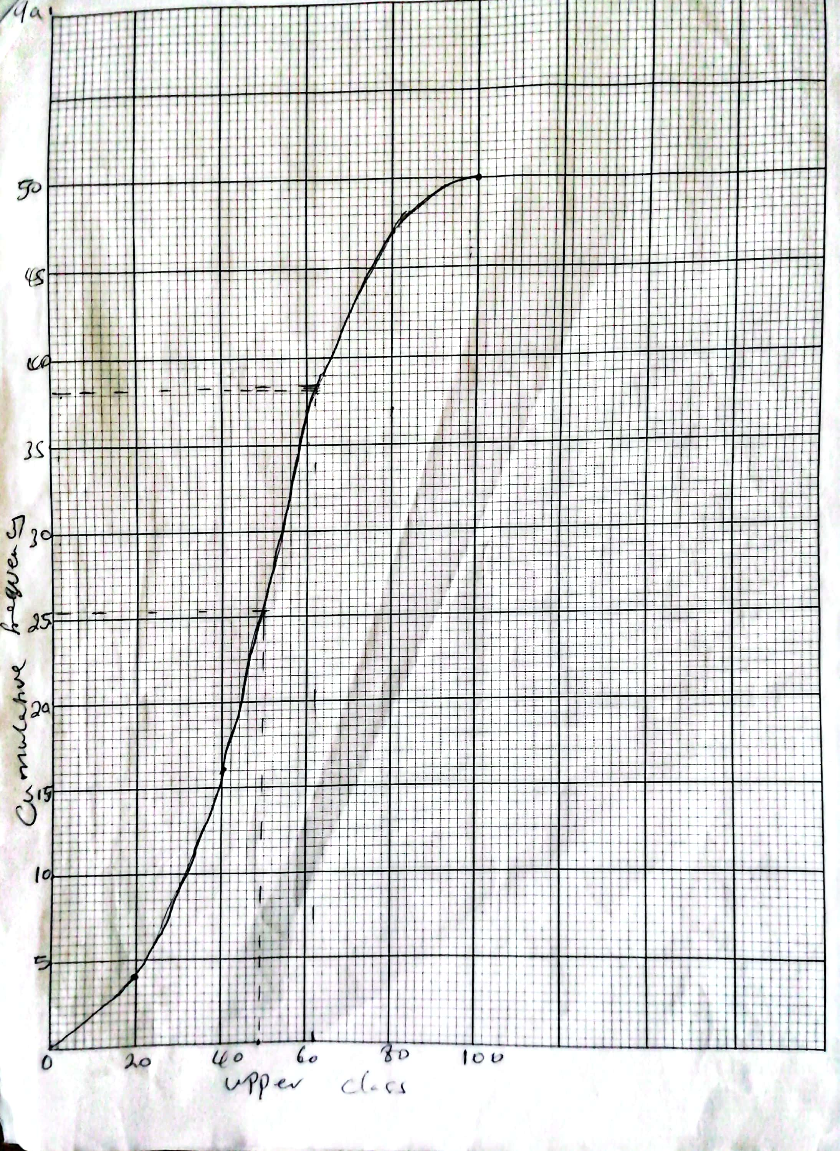

a (ii) $\frac{75}{100}$ $×\left(1+50\right)$ = 38. 25 1mk
75 percentile = 62 marks 1 mk
Median = $\frac{1}{2} {(1+50)}^{m}$
= 25.5^{m} 1 mk
Median = 50 marks 1 mk
n = 3
b. i. P(b) = 0.55
P(G) = 0.45
(b +G)³ = b³ + 3b²G+ 3bG² + G³
P ($≥2 boys)={\left(0.55\right)}^{3}+3{\left(0.55\right)}^{2} (0.45)$ 2 mk
= 0.1664 + 0.4084 2 mk
= 0.5748 1 mk

P ($≤1 boy)=3(0.55){\left(0.45\right)}^{2} +({0.45)}^{3}$ 2 mk
= 0.3341 +0.0911 2 mk
= 0.4252 1 mk
Or
P ($≤1 boy)=$1 – 5248
= 0.4252
10. a. (i) F= M $\frac{v-u}{t}$
F = $\frac{5[8i-6j+3k-\left(-2i-18j+13k\right)]}{10}$ 2 mk
= $\frac{[10i-12j-10k]}{2}$ 2 mk
= 5i + 6j - 5k 1 mk
(ii) |F| = $\sqrt{5^{2}+6^{2}+{(-5)}^{2}}$
= $\sqrt{25+36+25}$ 1 mk
= $\sqrt{86}$ 1 mk
= 9.27 1 mk

(b) Sum of ox components
B$\cos{θ+19 \cos{75-5N-20 \cos{55}}}$ = 0 1 mk
B$\cos{θ= -14. 92+16.47}$ 2 mk
B$\cos{θ= 11.5}$ 1 mk
Sum of oy components
B$\sin{θ+20 \sin{55°-19\sin{75°=0}}}$ 1 mk
B$\sin{θ=18.35-16. 38 }$ 2 mk
B$\sin{θ=1.97}$
$\frac{B\sin{θ}}{B\cos{θ}}= \frac{1.97}{11.55}$
$\tan{θ=0.197 }$ 1 mk
$θ= \tan^{-1}{(0.1706)}$
$θ=$9.68$°$ 1 mk
B$\cos{9.68=11.55}$
B = $\frac{11.55}{\cos{9.68}}$ 1 mk
B = 11.71 N 1 mk

END OF MARKING KEY

